International Institute of Professional Studies

Devi Ahilya Vishwavidhalya

Indore , MP

**PROJECT REPORT**

**ON**

**Musify App**

This Project is Submitted for VI semester

For degree of

Master of Computer Application-2020

Guided By : Submitted By :

Dr.Rahul Singhai Rohan Telang (IC-2K17-82)

**DECLARATION**

I am here by declare that the project entitled “**Musify APP**” which is submitted by **Rohan Telang** **(IC-2k17-82)** for the partialfulfilment of master of computer application (6Years) **VI** **Semester** of international institute of professionals studies , DeviAhilya Vishwavidyalaya , Indore ,comprises our own work and due acknowledgement has been made in text to all other material used.

The mater embodied in this project work is authenticated and is genuinely done by me and has not been submitted to this university or any other university / institute.

I have completed this project work during our VI semester session under the supervision of Dr. Rahul Singhai Senior Lecturer, IIPS, DAVV, Indore.

Signature of student:



Date:20/07/2020

Place: Indore

**CERTIFICATE FROM GUIDE**

It is to certify that project on " **Musify APP** ” which is submitted by **Rohan Telang (IC-2K17-82)** to international institute ofprofessional studies , Devi Ahilya Vishwavidyalaya , Indore hasbeen completed under my supervision and the work is carriedout and presented in a manner required for it's acceptance inpartial fulfilment for the award of degree of “ Master of Computer Application (6Yrs) ” Semester VI.

**Project Guide**

Signature:

**Name:** Dr. Rahul Singhai

**Date:**

**CERTIFICATE**

It is to certify that we have examined the project on **“** **Musify App”** which is submitted by **Rohan Telang (IC-2K17-82)** International institute of professional studies, Devi Ahilya Vishwavidyalaya, Indore and here by accord our approval of it as a study carried out and presented in a manner required for its acceptance in partial fulfilment for the award of degree of “Master Of Computer Application (6Yrs)” Semester VI.

**Internal Examiner** **External Examiner**

Signature : Signature :

Name : Name :

Date : Date :

**ACKNOWLEDGEMENT**

We acknowledge our sincere thanks to those who have contributed significantly to this project. It is a pleasure to extend deep gratitude to our internal guided Dr.Rahul Singhai , IIPS, for his valuable guidance and support and to continuously prompt us for the progress of the project. I thank him for his valuable suggestion towards my project, which helped me in making this project more efficient and user friendly.

We thank and acknowledge each and every ones efforts that helped me in some or the other way for small and significant things.

**ABSTRACT**

The project entitled “ Musify App ” is developed for the Entertainment purpose. It is an music streaming web application. Users enjoy latest songs. Also users can create albums and upload songs in it. User has full access to modify their albums such as update, insert and delete songs and albums. You can add your favourite songs to playlist. You can access website on phone as well as pc. It is fully responsive website.

**TABLE OF CONTENTS**

Topics Page No.

1. **INTRODUCTION** 
   1. Background problem
   2. Purpose
   3. Scope
   4. Methodology
2. **AIM & OBJECTIVE OF STUDY**
   1. Aim
   2. Objective
3. **SYSTEM DEVELOPMENT LIFE CYCLE** 
   1. **Feasibility Study**
      1. Economical feasibility
      2. Technical feasibility
      3. Legal feasibility
   2. **Analysis**
      1. Existing system
      2. Proposed system
      3. Data flow diagram (DFD)
   3. **Planning** 
      1. Specific requirement
      2. External interface requirement
      3. Hardware requirement
      4. Software requirement
      5. Performance requirement
   4. **Design**
      1. Entity definition
      2. Attribute definition
      3. Relationships
      4. E-R Diagram
      5. Flow diagram
   5. **Implementation**
   6. **Testing** 
      1. Unit testing
      2. Integration testing
      3. Validation testing

**3.7 Maintenance**

1. **FUTURE SCOPE OF APP**
2. **CONCLUSION**
3. **BIBLIOGRAPHY & REFERENCES**

**INTRODUCTION**

**1.1 Background problem**

Since it is not a full fledged and popular music streaming website, we don’t have every songs in our database. Also we didn’t use any API of other websites, therefore admin and users have to upload songs and albums manually.

**1.2** **Purpose**

* This application will make it possible to get entertained anywhere and at any time.
* It is not that complicated to use due to its user friendly interface.
* Administrator and also users has rights to change update and modify music and albums in the database.
* Any user can view and search song easily. Login id and password is needed.

**1.3 Scope**

* Web based application which will help in enjoy your favourite songs.
* Easy to use the website.
* An online app will reduce complexity.
* This project will provide an efficient platform to listen music
* This system will work efficiently and correctly as far a computer technology is concerned.

**1.4 Methodology**

A methodology is a model, which is employed for the design, planning, implementation and achievement of the project objectives. Methodology has many research dimension and methods. Methodology is the underlying principles and rules that govern system method , on the other hand it is a systematic procedure for a set of activities. I have used **Django Freamwork** , which used to develop web applications , as well as HTML5 applications with HTML , JavaScript, CSS and bootstrap.

Using MySQL as database.

It has the following features:

* Good user interface.
* User setting management.
* Storage management (saving and loading any kind of data).
* Window management.
* Wizard framework (support step - by - step dialogs).
* Django Framework libraries.
* Integrated development tools.

**AIM & OBJECTIVE OF STUDY**

**2.1 AIM :**

The aim of application to enjoy your favourite music.

The application is for listen music.

It has 2 level of users

a. Administrator level

b. User level

The application includes:

Music Albums

Song files

Facility to update, insert and delete songs and albums

Playlist of your favourite songs

Player

**2.2 OBJECTIVE:**

The main objective of the application is to provide ease of enjoying your favourite songs in your phones, tablets and pc . A lot of songs can be accessed very easily on this application .user can view songs and album easily in minimal amount of time . Songs and albums available on one touch . The another sub objective of our project is to provide all features that every music streaming websites have . The system is also provided with the mp3 files of songs which can also be downloaded by the users .

**Systems Development Life Cycle**

**(SDLC)**

System Development Life Cycle is a conceptual model used in software development projects. In this method, there is a possibility of combining two or more project management methodologies for the best outcome. Therefore we have used waterfall Model along with SDLC. SDLC also heavily emphasizes on the use of documentation and has strict guidelines on it.

**Waterfall Model**

This is the legacy model for software development projects. This methodology has been in practice for decades before the new methodologies were introduced. In this model, development life cycle has fixed phases and linear timelines. The Waterfall Model is a sequential software development process, on which progress is seen as steadily downwards ( like waterfall ) through phases of requirement, design, implementation, verification and maintenance.

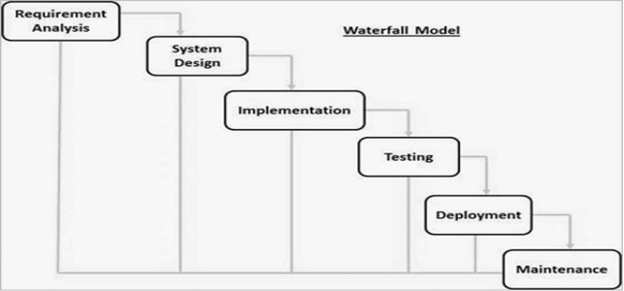

**3.1 Feasibility study**

Feasibility is a measure of how beneficial the development of the music system will be to users.This is done by investigating the existing system in the area under investigation or generally ideas about a new system. It is a test of a system proposal according to it's workability, impact on the users, ability to meet user needs, and effective use of resources. It focuses on three major questions:

1. What are the user’s demonstrable needs and how does a candidate system meet them?

2. What resources are available for given candidate systems? Is the problem worth solving?

3. What are the likely impacts of the user system? How well does it fit within the user’s master MIS plan?

Each of these questions must be answered carefully. They revolve around investigation and evaluation of the problem ,identification and description of candidate systems, specification of performance and the cost of each system ,and final selection of the best system.

Three key considerations are involved in the feasibility analysis:

1. Economic

2. Technical

3. legal

**3.1.1 Economic feasibility**

Economic analysis is the most frequently used method for evaluating the effectiveness of a proposed system. It is more commonly known as cost benefit analysis, the procedure to determine the benefits and saving that are expected from a candidate system and compare them with costs. If the benefits out weight costs then a decision is made to design and implement the system. Otherwise make alterations in the proposed system.

The innovation of the new system has much influence on the economical side of the company. Manual system is highly cost driven due to the high labour costs. So if a user registers with the Musify app , he can enjoy their day -to - day activities with free and relax mindset . Thus the system is economically feasible.

**3.1.2 Technical feasibility**

In examining Technical feasibility of the system, more importance

is given to the hardware interaction part of the system. The

assessments of technical feasibility centers on the existing system and

to what extent it can support the proposed addition. This was based on

an outline design of system requirements in turns of inputs, files,

programs, procedures, and staff. It involves financial considerations to

accommodate technical enhancements. Online test management tool

being a web based application, it uses.Net framework, 800MHZ

computer , 20GB Hard disk.

**3.1.3 Legal feasibility**

People are inherently resistant to change, and computers have

been known to facilitate change. An estimate should be made about the reaction of the user staff towards the development of a computerized system.

Computer installations have something to do with turnover,

transfers and changes in job status. The introduction of a candidate

system requires special effort to educate, sell and train the staff for

conducting the business.

The system is designed such that even a computer ignorant

person can interact with the system freely. So the system requires not

much effort to train and educate people, the system is that much legally feasible.

**3.2 Analysis**

Analysis is the process of breaking a complex topic or substance into smaller parts in order to gain a better understanding of it.  
 We divided our project into small modules like interface module has many sub-parts which were individually made to achieve our desired goal.

**3.2.1 Existing system**

The Existing system of music streaming app is manual. It has so many problems. So i introduce a new system, which is fully computerized. Existing system is a large manpower process and is difficult to implement. Working of existing system is given below:-

All the songs are stored in database are secured and safe. Songs are stored according to their album. You can modify music and album. You can also search songs and add your favourite songs to the playlist. Administrator have an admin panel to control website.

**3.2.2 Proposed system**

The main objective of the Musify App is that it helps to any number of transactions for any number of candidates/users at a time, in an automated manner. It reduces the time consumption and workload that exist in the current system.

The main purpose of the system is to efficiently evaluate the candidate thoroughly through a fully automated system that not only saves a lot of time but also gives fast results. It is a cost - effective and popular means of mass - evaluation system.

**3.2.3 Data Flow Diagram**

A data flow diagram (DFD) is a graphical representation of the "flow" of data through an information system, modeling it's process aspects. A DFD is often used as a preliminary step to create an overview of the system without going into great detail, DFDs can also be used for the visualization of data processing (structured design).

A DFD shows what kind of information will be input to and output from the system, how the data will advance through the system and where the data will be stored.

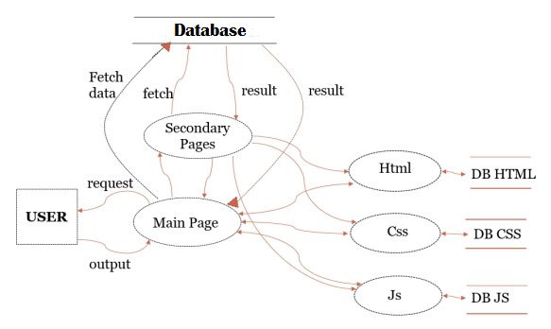

**Fig. DFD**

**3.3 PLANNING** Planning is the process of thinking about the activities required to achieve a desired goal. It involves the creation and maintenance of a plan, such as psychological aspects that require conceptual skills. There are even a couple of tests to measure someone’s capability of planning well.   
 We have plan our interface in which there will be multiple options that will help user to access the intended music.

**3.3.1 Specific requirements**

Since the Administrator and the user are the main target group of our software, we will only concern about some important functions for the admin and the user.

Administrator:-

* The administrator can manipulates and maintains the system.
* He is responsible for creating data for accessing. Adding all mp3 fies and images.
* Again, he can add and modify data to the database.
* He can decide how the data is to be displayed in the application.

Users:-

* Can access app.
* After sign up, use application.
* Open the application user will see the main page with slide panel button.
* Clicking on slide panel button user see the menu.
* Select the options from menu user will be directed to secondary pages.

**3.3.2 External Interface Requirements**

It include the following interfaces

* User interfaces
* Software interfaces
* Hardware interfaces

**User Interfaces:-**

The interface must be easy to understand. The user interface includes :

* **screen formats/ organization**: The introductory screen will be thefirst to be displayed which will allow the users to go to slide panel.
* **window format/ organization**: When the user chooses some otheroption, then the information pertaining to that choice will be displayed in a new window which ensures multiple windows to be visible on the screen and the users can switch between them.

**Hardware Interfaces:-**

1. Server side hardware

· Hardware recommended by all the software needed.

· Communication hardware to serve client requests

2. Client side hardware

* Hardware recommended by respective client’s operating system and

web browser.

* Communication hardware to communicate the server.

**Software Interfaces:-**

Server side software

* Web server software
* Server side scripting tools: javascript
* Database tools
* Compatible operating system: android operating system, windows,mac

communications interfaces:-

http : Hypertext Transfer Protocol is a transaction oriented client / server

protocol between web browser & a web server.

TCP/IP**:** Transmission Control Protocol / internet protocol , the suite of

communication protocols used to connect hosts on the internet.

Tcp/ip uses several protocols, the two main ones being TCP and IP.

**3.3.3 Hardware Requirements**

**Processor:** Intel dual core

**Ram :** 2GB

**3.3.4 Software Requirements**

**Operating System:** Windows OS

**Front End:** HTML, CSS, Bootstrap

**Back End:** JavaScript , Django

**Web server:** Internet Connectivity

**Browser:** Any

**3.3.5 Performance Requirements**

* System should be able handle multiple users
* Database updating should follow transaction processing to avoid data

inconsistency.

**3.4 DESIGN**

Design phase is the creation of a plan or convention for the construction of an object, system or measurable human interaction.  
 We have designed our application with a main page and connected it to the secondary pages which will fetch data from database .

**3.4.1 Entity definition**

Entity are the principle data object about which information is to be collected. Entities are either concrete or abstract such as a person ,place, things or event which have relevant to database.

**3.4.2 Attribute definition**

The attribute that are identified as part of the entities are listed along with their descriptions, data types and attribute name.

**3.4.3 Relationships**

* One –to –one
* One –to –many
* Many –to –many

**3.4.4 E-R Diagram**

An entity relationship model , also called an entity - relationship (ER) diagram , is a graphical representation of entities and their relationships to each other , typically used in computing in regard to the organization of data within databases or information state . An entity is a piece of data - an object or concept about which data is stored.

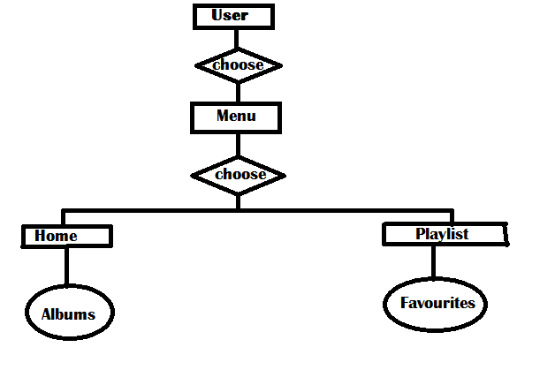

**3.4.5 FLOW CHART**

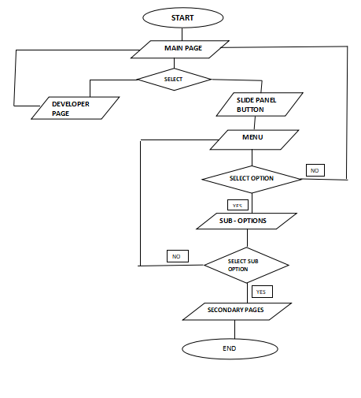

**3.5 IMPLEMENTATION**

Implementation is the stage in the project where the theoretical design is turned into a working system and is giving confidence on the new system for the users that it will work efficiently and effectively .It involves careful planning, investigation of the current system and it's constraints on implementation , design of methods to achieve the change over ,an evaluation , of changeover methods . Apart from planning major task of preparing the implementation are education and training of users.The more complex system being implemented, the more involved will be the system analysis and the design effort required just for implementation.

An implementation co-ordination committee based on policies of individual organization has been appointed .The implementation process begins with preparing a plan for the implementation of the system.

According to this plan ,the activities are to be carried out ,discussions are made regarding the equipment and resources and the additional equipment has to be acquired to implement the new system.

Implementation is the final and important phase .This is the most critical stage in achieving a successful new system and in giving the users confidence that the new system will work is effective .

The system can be implemented only after thorough testing. This method also offers the greatest security since the old system can takeover if the errors are found or inability to handle certain type of transactions while using the new system .

**3.6 TESTING**

System testing is the stage of implementation, which is aimed at ensuring that the system works accurately and efficiently before live operation commences .Testing is vital to the success of the system . Testing is the process of executing a program with the explicit intention of finding errors that is making the program fail . The tester may analysts , programmer or a specialist trained for software testing ,is actually trying to make the program fail .Analysts know that an effective testing program does not guarantee system reliability .Therefore reliability must be designed into the system.

Testing brings all the pieces together into a special testing environment, then checks for errors, bugs and interoperability.  
The PhoneGap Desktop app starts a small web server to host your project   
 and once connected to that web server, the PhoneGap Developer app runs  
 your project on your mobile device.  In which all our developed module   
 are integrated together and are tested for bugs .

**3.6.1 Unit Testing**

In unit testing we have to test the programs making up the system . For this reason unit testing is sometimes called as the program testing. The software units in a system are modules and routines that are assembled and integrated to perform a specific function.

Unit testing focuses first on modules ,independently of one another , to locate errors .This enables ,to detect errors in coding

and logic that are contained within the module alone .Unit testing can be performed from the bottom up ,starting with the lowest level modules and proceeding one at a time .Unit testing is done for each module in online test management tool. This ensures that the value we enter match with the data type and within the specified limit.

**3.6.2 Integration Testing**

Data can be lost across any interface ,one module can have an adverse effect on another ,sub functions when combined ,may not produce the desired major functions .Integration testing is a systematic testing for conducting tests to uncover errors associated within the interface .The objective is to take unit tested modules and build a program structure . All the modules are combined and tested as a whole . Here correction is difficult because the vast expenses of the entire program complicate the isolation of causes. Thus in the integration testing step , all the errors are corrected for the next testing steps . in online test management tool , each module is integrated and tested .This testing provides the assurance that the application is well integrated functional unit with smooth transition of data .

**3.6.3 Validation Testing**

At the culmination of integration testing ,software is completely assembled as a package ; interfacing errors have been recovered and corrected and a final series of a software tests - validation tests begin. Validation testing can be defined in many ways but a simple definition is that validation succeeds when the software functions in a manner that can be reasonably expected by the customer .

Invalidation testing if user wants to enter the numeric value he can only enter the numeric value not the text value. For e.g. :in phone number field user can only enter numeric value to it .The system is user friendly with user guide and messages to explain further procedures .An attempt has been made to perfect the process by incorporating validation at each level .

**3.7 MAINTENANCE**

During the maintenance stage of the SDLC, the system is assessed to ensure it does not become obsolete. This is also where changes are made to initial software. It involves continuous evaluation of the system in terms of its performance.

In the maintenance phase of SDLC we can add-on new content and update our application according to change in information of the institute.

**SCREENSHOTS**

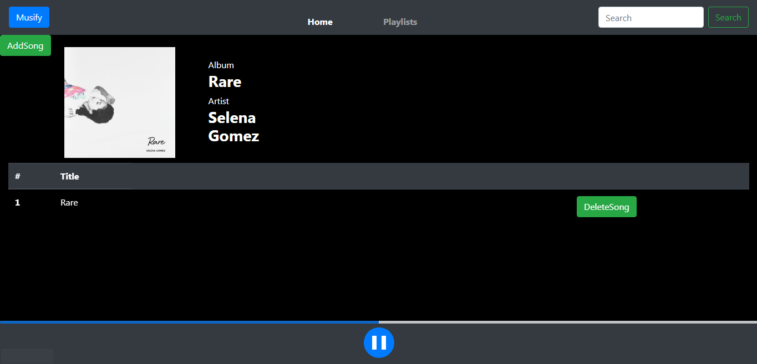

**Player**

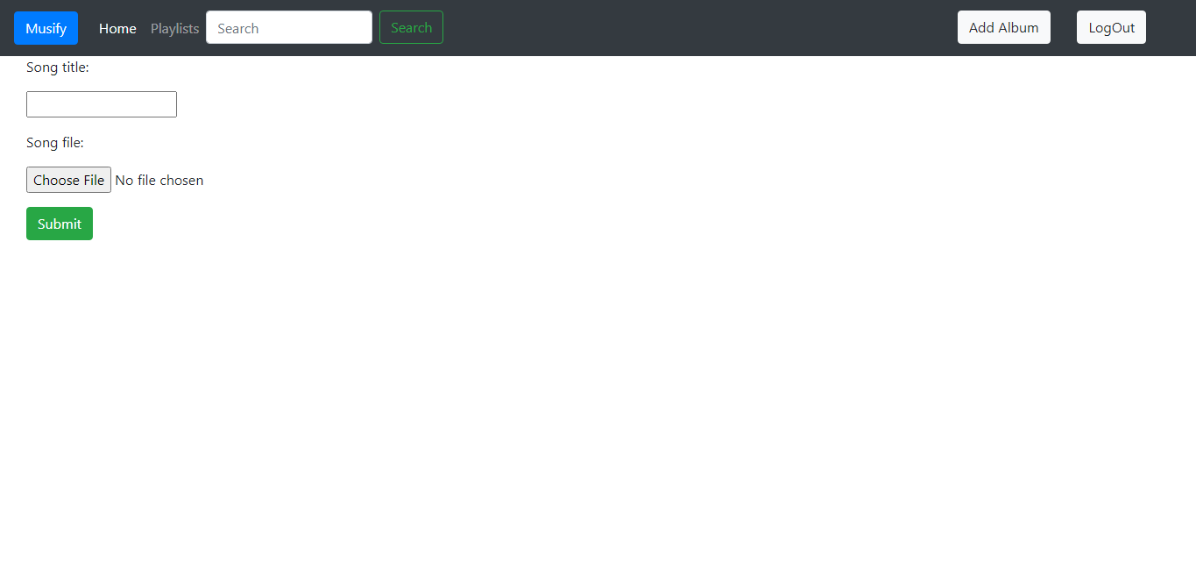

**Add song**

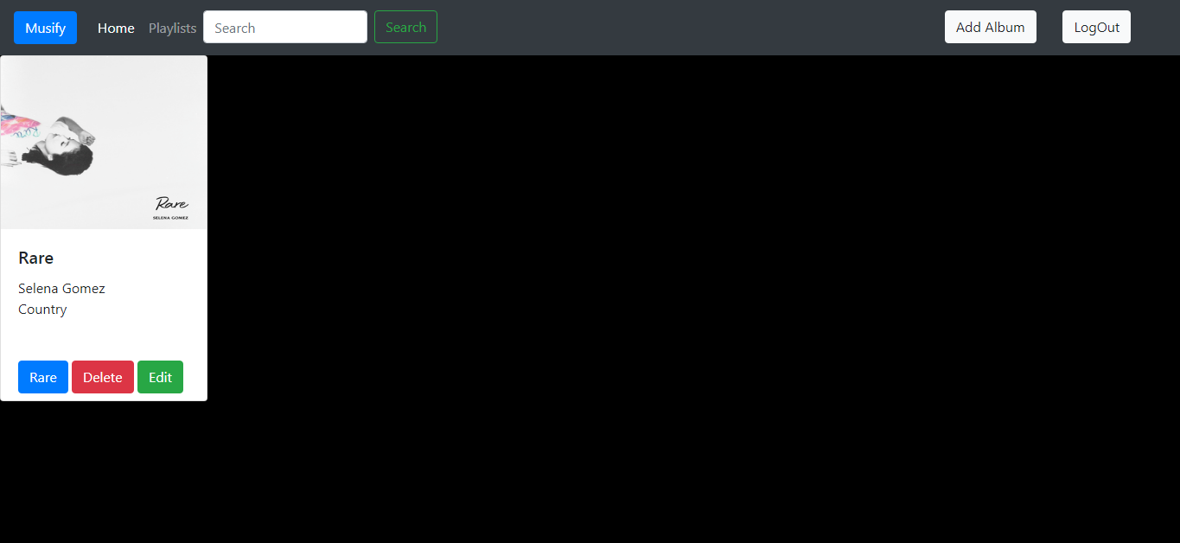

**Home Page**

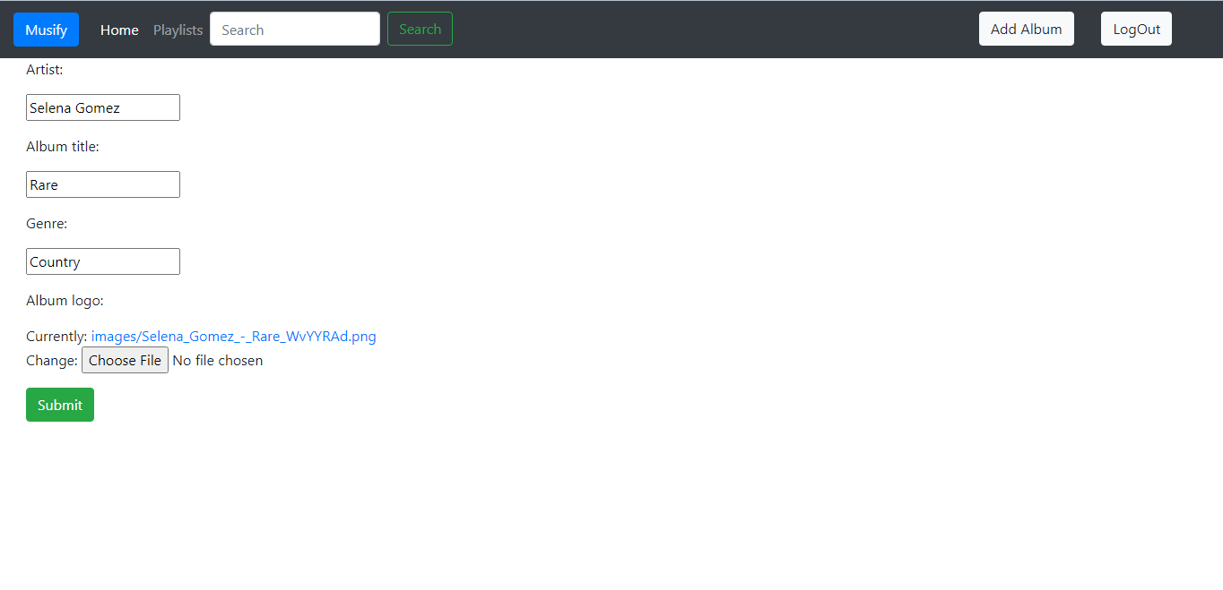

**Edit Album**

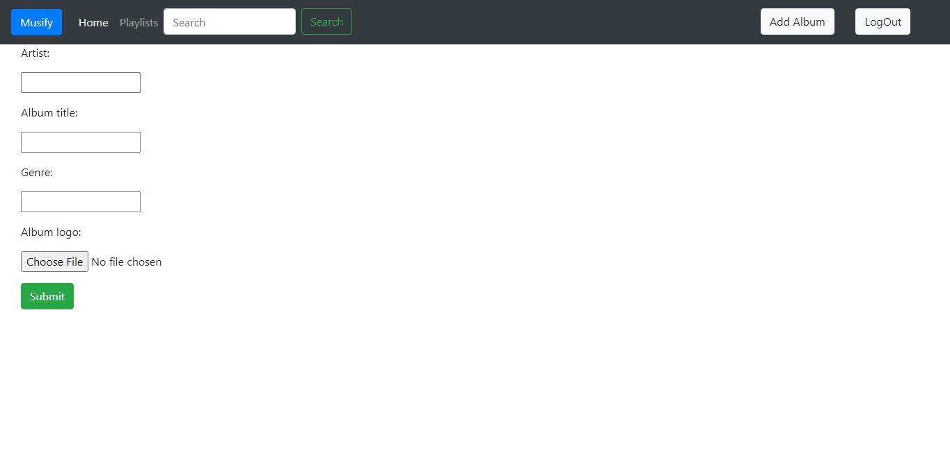

**Add Album**

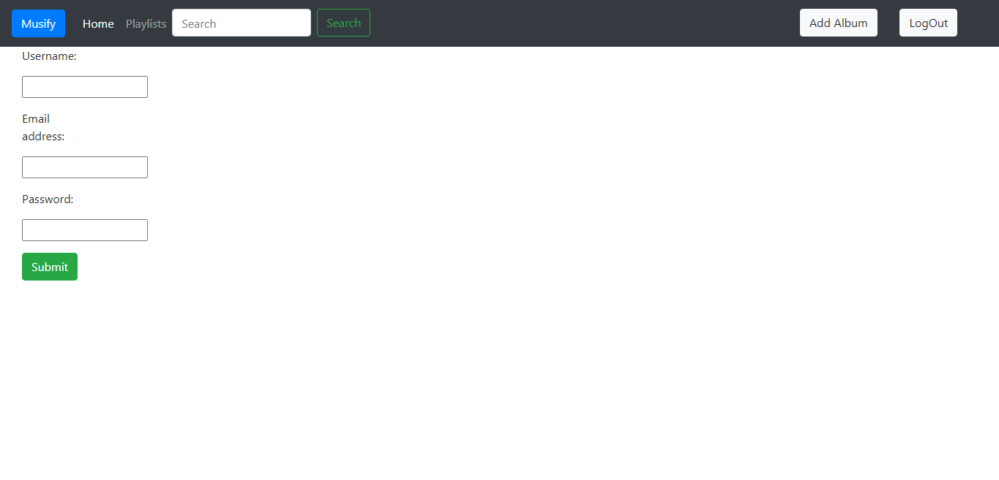

**Registration**

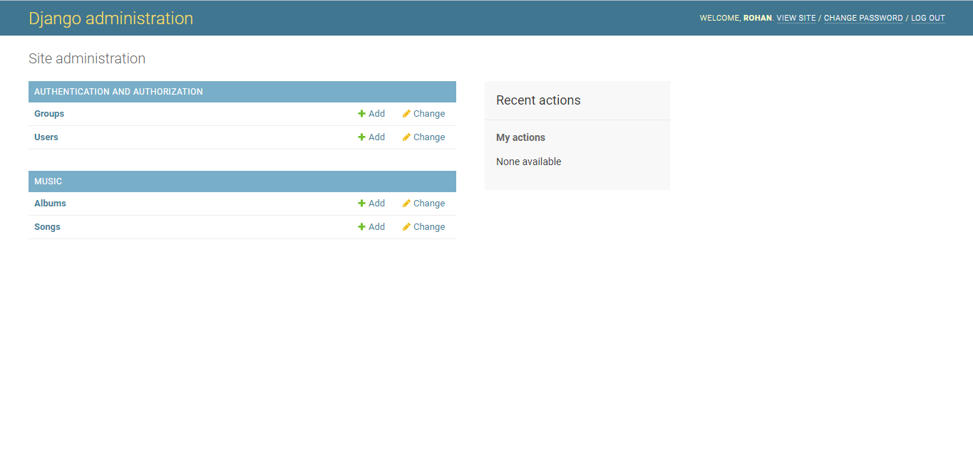

**Admin Penal**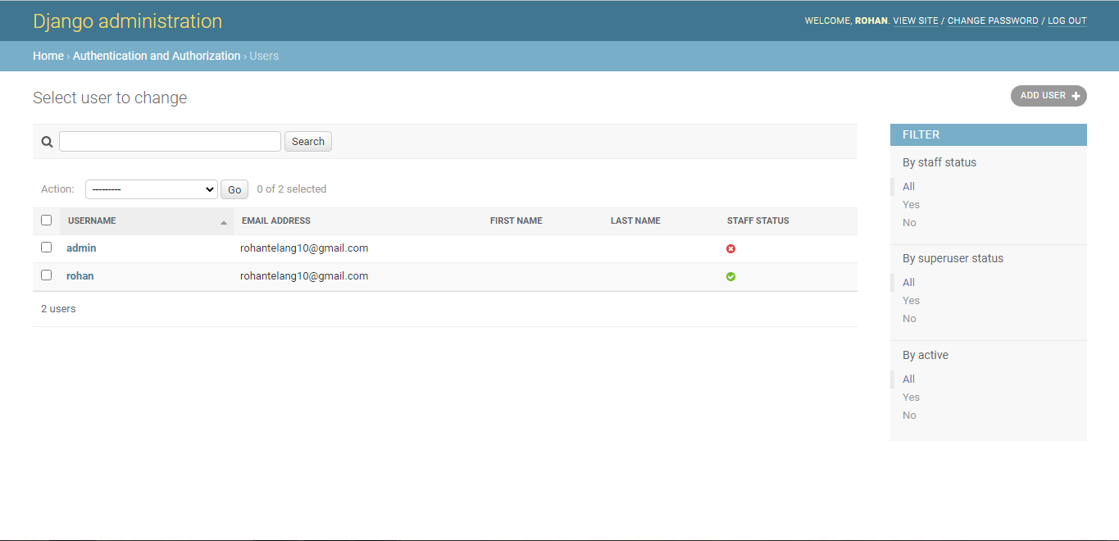

**Admin users**

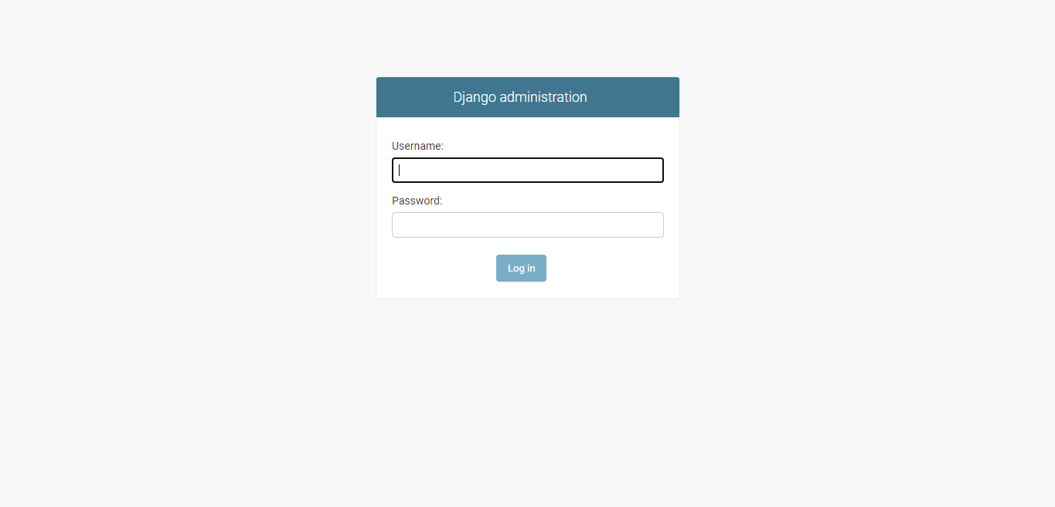

**Admin login**

**FUTURE SCOPE OF APP**

In the future version of these application will get some important updates. Some of them are following-

* I will add API of spotify to get latest music and also almost all songs and albums.
* I will try to work on users feedback.
* It will get direct sign in option from google. No need to fill all the personal information.
* It will get some audio oriented feature.

**Conclusion**

Music Streaming app has been developed and the system was tested with proper data .The system results in regular timing preparation of the required output .In comparison with the manual system ,the benefit under a computer system considerable into saving of manpower , working hour and efforts .

It can observe that the information required can be obtains with ease and accuracy in the computerized system .The user with minimum knowledge about computer can be able operate the system easily Use Case Diagram identification techniques have been used to implement accuracy of data in allformats of input .The system has produced all the report required by the management .

In this software additional features can be added without interrupting the normal functioning of the system .

**Bibliography and Reference**

**1. Reference Books**

DBMS : Elmasri and Navathe “ Fundamentals of Database System”, 3 rd edition

HTML : HTML by Herbert's child

**2. Other Documents and Resources**

<http://www.w3schools.com/>

<https://www.djangoproject.com/>

<https://www.getbootstrap.com/>

http://www.youtube.com/thenewboston/

http://www.youtube.com/CodeWithHarry/